# Solution Template for A4 BUG1

# Name: Ty Saunders

# Student ID:

# Assignment details: Debugging task

# A4 Bug Report

## Bug 1: Incorrect calculation of fines.

When an item is returned late, customer is quoted a correct late fee of $1 per item per day late. However, the amount being recorded against their account is 3 times the expected amount.

Step 1: Return an item late

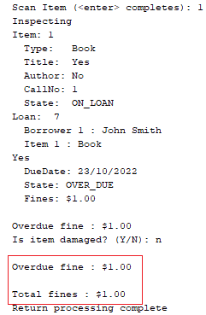

Step 2: You can see the amount is 3 times greater when using list patron, or pay fine:

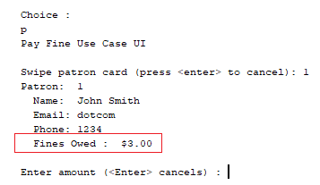

Bug 1 Replication:

**System Test:** The steps to manually reproduce the error are in **Bug1SystemTest.docx**.

**Automated Test:** Test case has been written to replicate this bug quickly. It can be run by opening the project, found in this directory: **A4\src\test\java\library.Bug1Test.java**

The test can be run by opening the project, right-click the library test package and click “Test Package”:

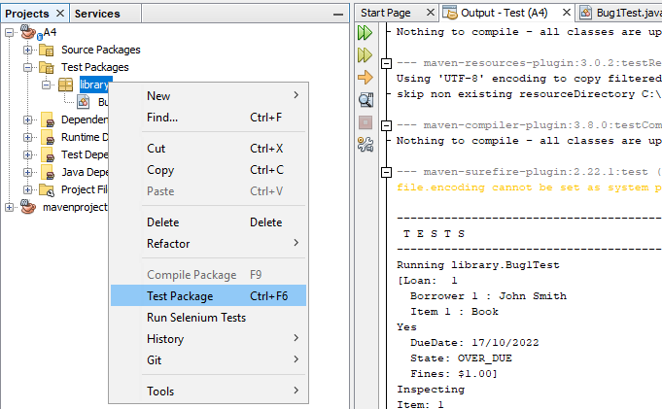

**A screenshot of the test code:**

# 

Version control: Screenshot of commits:

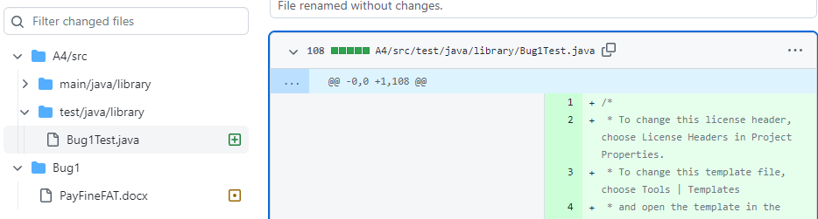

**Bug 1 Tracing:**

H0 – The payFineUI is displaying the result wrong

T0 – Do a static review of the PayfineUI to look for errors.

R0 – FALSE: Did not see anything at all related to displaying the fine or calculating it – moving on.

H1: Main method displaying wrong when PayFine is chosen

T0: Static review of MAIN.java to see what it might be displaying when PayFine is called.

R0: FALSE: Main.java calls PayFineUI, then PayFineUI calls PayFineControl.cardswiped(): This method gets patron id, and tells the UI to display the patron object. Investigated the Patron code: Can see that Patron’s toString method is not doing anything other than getting the fines owed, so issue exists before the PayFine process – it is nothing to do with payFine.

H2: Patrons incurFine method might be getting called with the wrong value

T0: Find where incurFine is being called and check what value is being passed by setting a break point.

R0: FALSE: incurFine gets called by Library during dischargeLoan using currentLoan.getFines as an input. Breakpoint was set and found that the variable is being set correctly here:

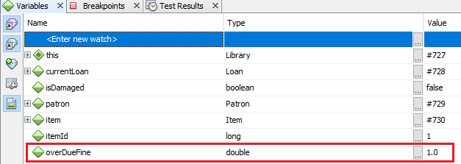

H3: Patron’s incurFine method might be getting called more than once.

T2: Scan the code base for other uses of incurFine method. Set a breakpoint on this line to check what value is being passed.

R2: TRUE: Found incurFine is getting called by ReturnItemControl during it’s dischargeLoan method using its “totalFines” variable as an input. By setting a break point we can see that incurFine is being called with 1.0. So we have accounted for $2 out of the $3

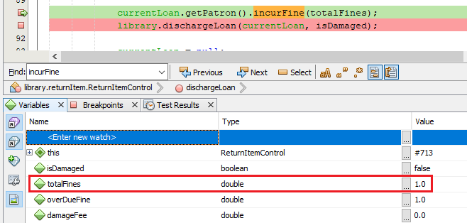

H4: Another method is adding an extra dollar somehow.

T4: Set break points to get the patrons fine amount after both incurFine methods and after library.dischargeLoan is complete.

R4: TRUE: After patron.incurFine is called within ReturnItemControl.dischargeLoan, the patrons late fees are $1.00. After incurFine is called again within Library.dischargeLoan, the late fee is $2.00. After Loan.discharge is called, the late fee increases to $3.00. Therefore another issue must exist somewhere during Loan.discharge.

After the first patron.incurFine is called:

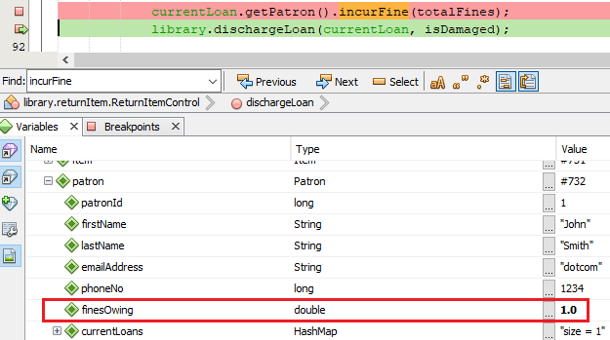

After the second patron.incurFines is called:

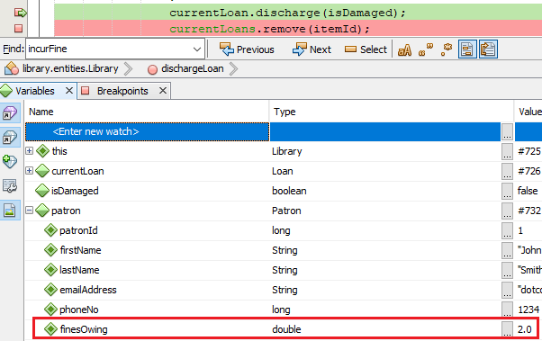

After loan.discharge is complete:

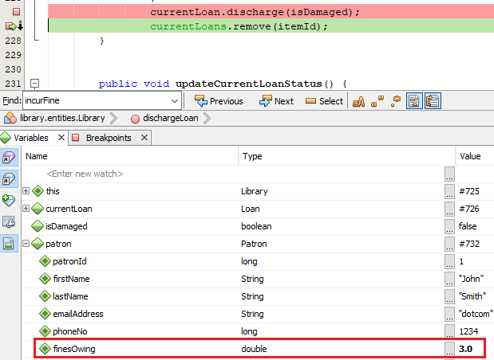

**H5: Another issue is occurring during Loan.discharge(), adding to the fine amount**

**T5: Review the Loan.discharge method to see where it is adding to the fee.**

**R5: FALSE: Loan.discharge is not adding any money directly. There are some methods it is calling from other classes which need to be investigated.**

**H6: Patron.dischargeLoan is adding to the late fee amount.**

**T6: Review of Patron.dischargeLoan to check what it is doing.**

**R6: TRUE – We can see that Patron.dischargeLoan is directly adding to the overdue fines.**

**Before patron.dischargeLoan adds to the fines the fine amount is $2:**

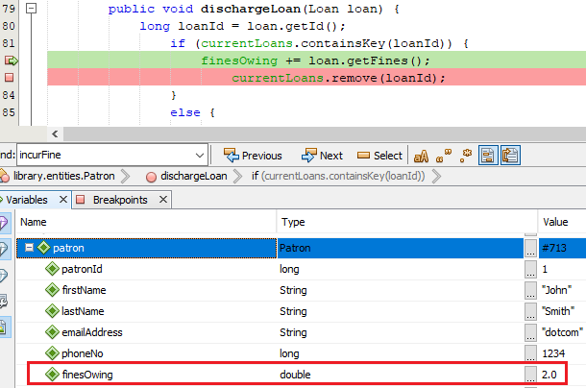

**After finesOwing is added to the amount of fines is $3:**

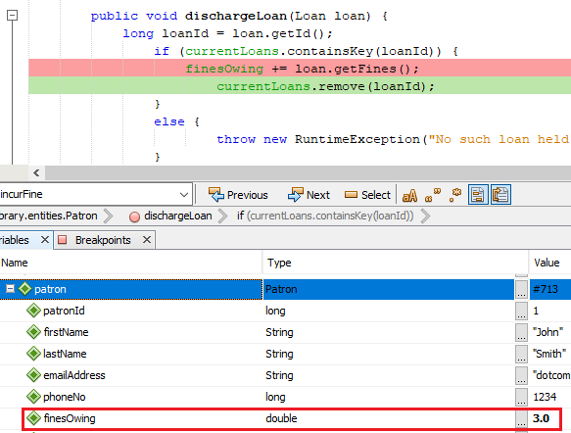

Conclusion of bug tracing:

There are 2 problems –

1. Patron.incurFine is being called twice, by ReturnItemControl and Library.
2. Patron.dischargeLoan is directly adding to the fine as well.

**Resolution**

**The fine is being added 3 times. It should only be added once.**

It is clear that the defect is that patron finesOwing variable is being added to 3 times instead of once. We could resolve this issue 3 different ways – 2 of the methods which add in fines need to be adjusted, and we must keep one.

In making this decision we see that Patron has a public incurFine method, so it makes sense that we use it. Therefore we can eliminate fine being added in patron.dischargeLoan. It also makes no sense for the return Item control to be having authority over fines so therefore we should remove the method from here as well. The patron.incurFine() method will be called during Library.dischargeLoan and will be removed from all other places it is called as the fix.

**Fix details:**

1. **Remove line 90 from ReturnItemControl’s dischargeLoan method:**



1. **Remove line 82 from Patron’s dischargeLoan method: finesOwing += loan.getFines();**



**Test screenshots with correct code**